How to install Microsoft Applications on personal devices:
- Navigate to your Office 365 web page at portal.office.com
- Log into your Lakeland email including the domain. (EX: username@lakeland.edu)
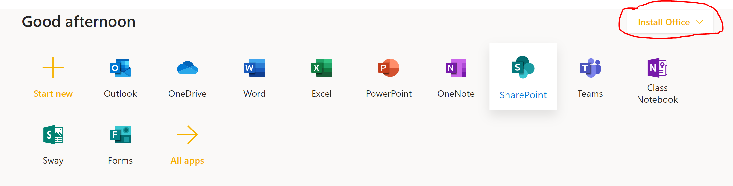
- On the top right, click on the drop down arrow and select “Office 365 apps”.
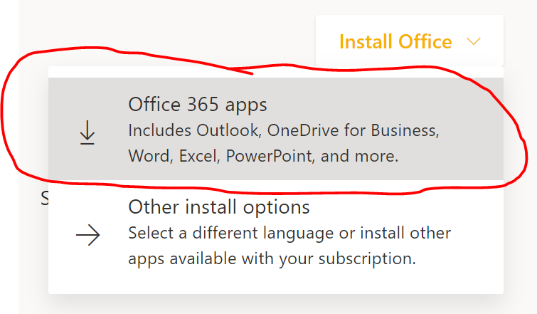
- The installation will take approximately 15-30 minutes.
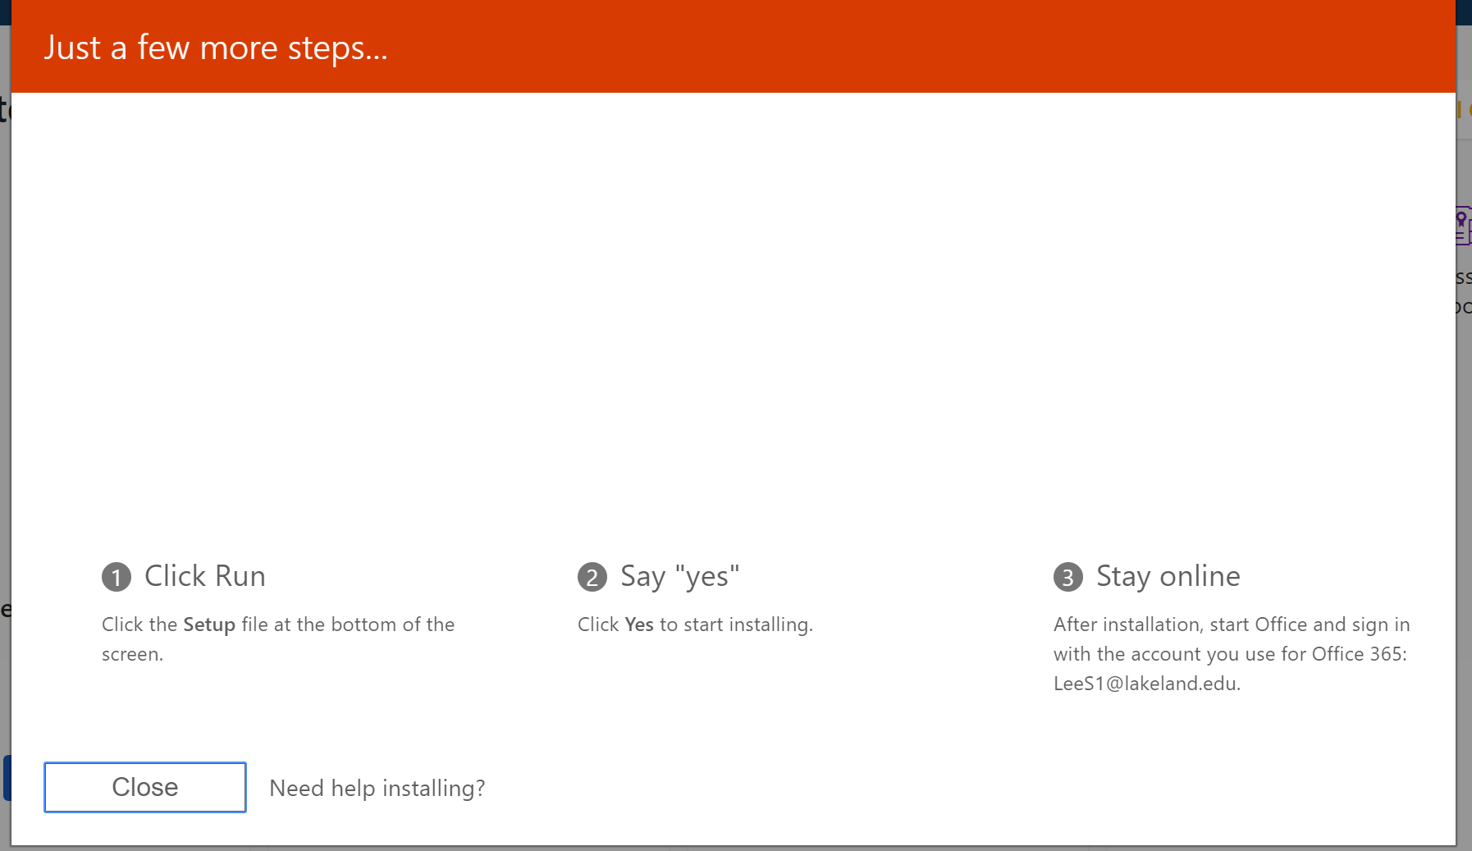
- The installation package should include Skype for Business, One Drive, Word, Excel, and Powerpoint.

